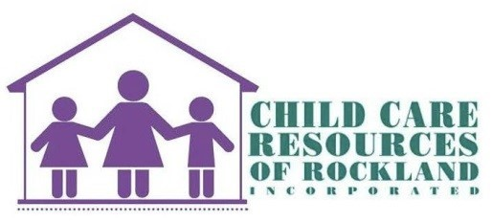

CARES ACT 3 Child Care Scholarship Direct Deposit form
To: Child Care Providers
From: Child Care Resources of Rockland, Inc.
Date: October 29, 2020
Re: Direct Deposit Enrollment REQUIRED FOR CARES 3 PAYMENT
Complete this form in order to receive the weekly tuition payment via direct deposit.

NAME ON ACCOUNT: _______________________________________________
BANK NAME: _____________________________________________________
Bank Routing Number_______________________________________________
The 9 numbers on the far left of the check, before the account number-NOT the deposit slip

BANK ACCOUNT NUMBER ____________________________________________

Authorized by ____________________________________________________
(Print your name)
Authorized by __________________________________________________
(Sign your name)

**Please submit this completed form along with a voided check to: ** childcarerockland@gmail.com or fax to (845) 425-5312
Child Care Resources of Rockland, Inc.
235 North Main Street - Ste. 11
Spring Valley, NY 10977
Hours of Operation 8:30am - 5:00pm Monday-Friday
Phone (845) 425-0009

