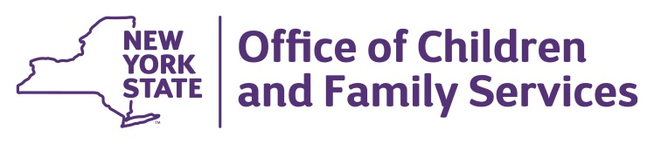
Andrew m. cuomo  Governor | SHEILA J. POOLE  Commissioner

March 11, 2020

Dear Provider:

OCFS has been working closely with the New York State Department of Health (DOH) to provide programs with up-to-date information regarding the Novel Coronavirus (COVID-19) and to provide timely responses to your questions. Please review this letter carefully.

REVIEW IMPORTANT INFORMATION

Take time to review emergency contact information for each of the children enrolled in your program. Additionally, now may be a good time to ensure families have access to the child’s most recent medical statement, and to ask parents to review and/or update their emergency contacts.

WHAT TO DO IF A PARENT IS QUARANTINED

In the event a parent of a child in your program must be quarantined, advise the parent they cannot enter the childcare program for any reason, including picking up their child. If the parent is exhibiting signs of illness or has been tested and is positive for the virus, they must utilize an emergency contact authorized by the parent to come pick up the child. If the parent is being quarantined as a precautionary measure, without symptoms or a positive test, childcare staff should walk out or deliver the child to the parent outside the childcare building. The child must not return to the childcare program for the duration of the quarantine.

SCREENING QUESTIONS

The following guidance is based on the most current Centers for Disease Control and Prevention (CDC) and NYS Department of Health (DOH) recommendations for prevention of the spread the novel coronavirus of 2019 disease (COVID-19) and the management of Persons Under Investigation (PUI). This guidance is not intended to address every potential scenario that may arise as this event evolves. OCFS encourages you to also utilize your Local Health Department and keep in close contact with your regional office, registration office, or enrollment agency staff.

When speaking with parents, visitors, and family members, consider asking the following three questions:

- Have you traveled to a country for which the CDC has issued a Level 2 or 3 travel designation (currently South Korea, Iran, Italy, China, Japan) within the last 14 days?

- Have you had contact with any Persons Under Investigation (PUIs) for COVID-19 within the last 14 days, OR with anyone with known COVID-19?

- Do you have any symptoms of a respiratory infection (e.g., cough, sore throat, fever, or shortness of breath)?

If the individual answers “yes” to any of the above, such individual must refrain from entering a childcare program. OCFS has developed a sign, included with this letter, that we recommend you print out and post at the entrance in order to help clarify the situation with families and other visitors. You can also find the sign on the OCFS website at: https://ocfs.ny.gov/programs/childcare/#COVID19

NOTIFY YOUR REGULATOR

As a reminder, if your childcare program is closing for issues related to COVID-19, you are required by OCFS regulation to immediately notify your regional office, registration office or enrollment agency. You should also notify your regional office, registration office or enrollment agency if a child in your program has been quarantined.

OCFS is committed to the health and well-being of New York’s children and families and we know that you are, too. We will continue to work with our partners to ensure that you have the latest updates. Please check the NYS DOH website regularly: https://www.health.ny.gov/diseases/communicable/coronavirus/

Sincerely,
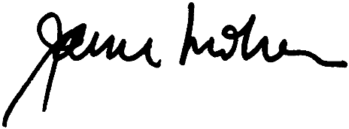
Janice Molnar, Ph.D.
Deputy Commissioner
Division of Child Care Services

